**I’m Having Trouble in TxEIS**

**What Can I Do?**



**Presented by ESC, Region 14**

**April 27, 2017**

# Best Practices

# Verification’s to Save Time Before submitting a Ticket

**_____1. TxEIS is only supported by the following browsers:**

Internet Explorer 11

Mozilla Firefox (Current Version) ***which we recommend using*.**

Safari 5.0 and later (Mac only)

Chrome (Current Version)

**To verify the version, you are currently running, select ‘Help’, then About:**

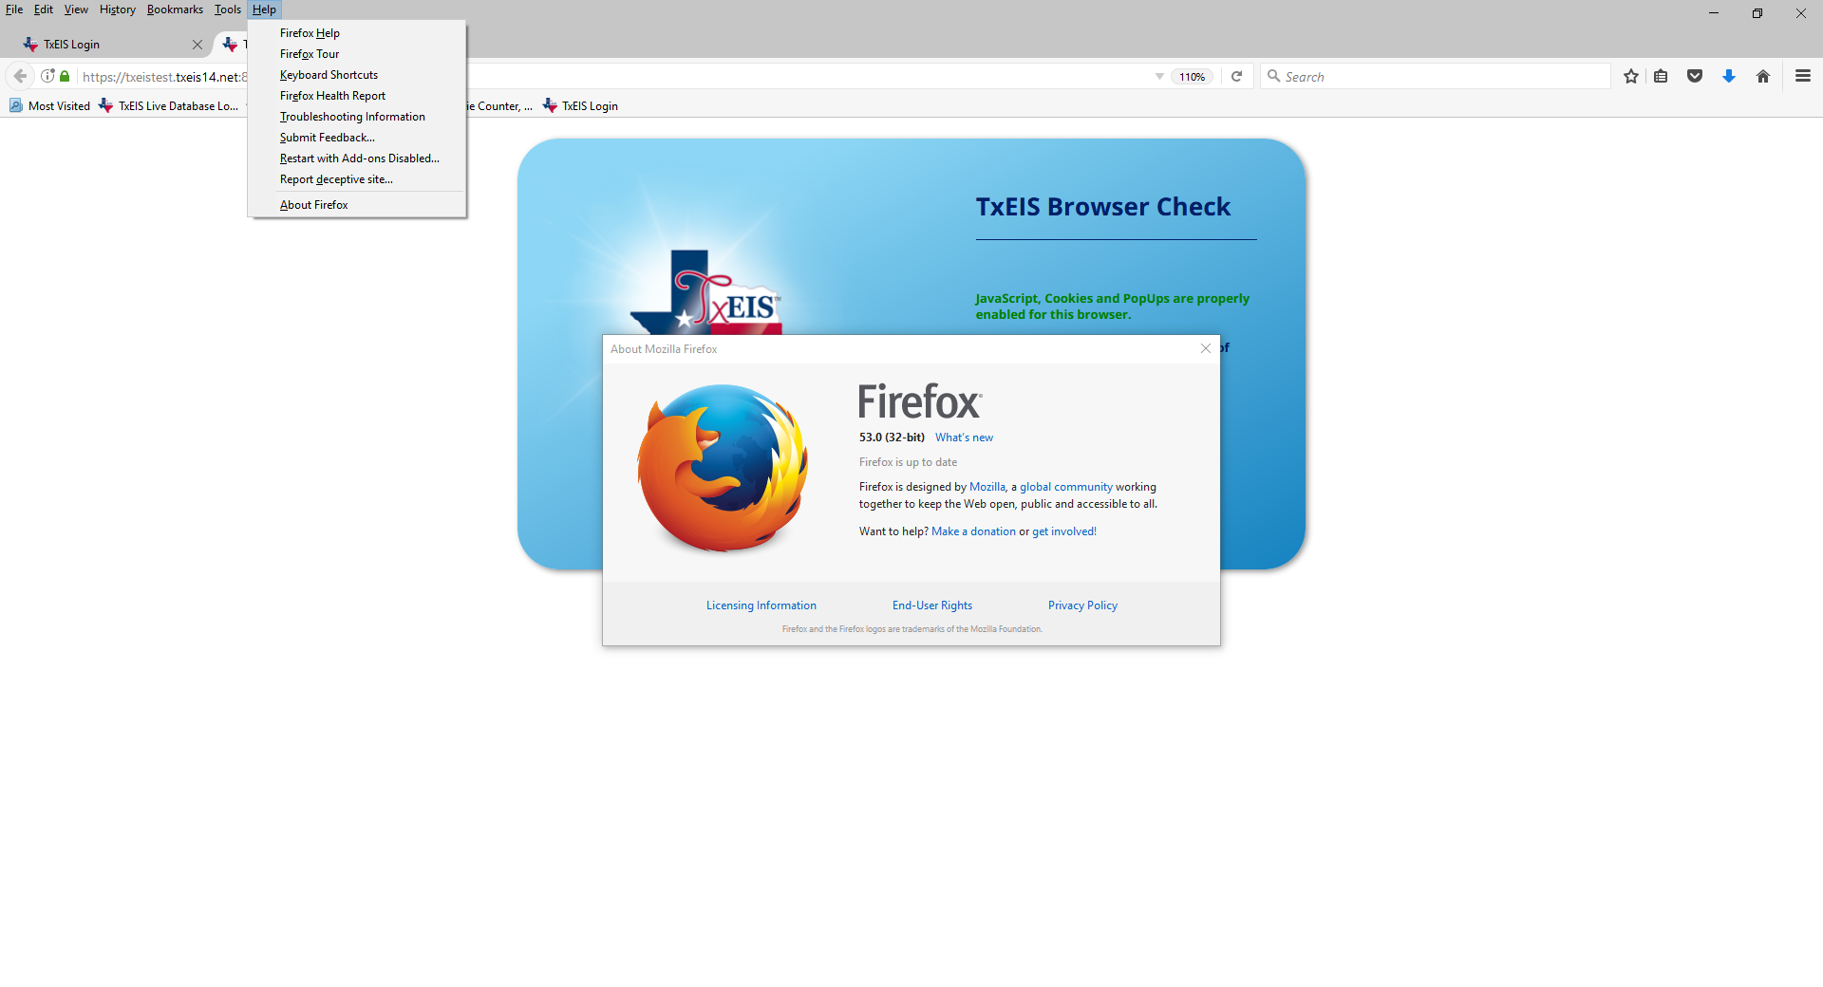

Things that can cause your browser settings to change include:

* New Updates - TxEIS
* The district tech may make changes to district computers
* Browsers may have updates

**_____2. Verify the Browser Settings**

To locate the most current recommendations for your Browser Settings, click on your TxEIS app. Go to the bottom of the Sign On Page and select the ‘Click Browser Settings’ link.

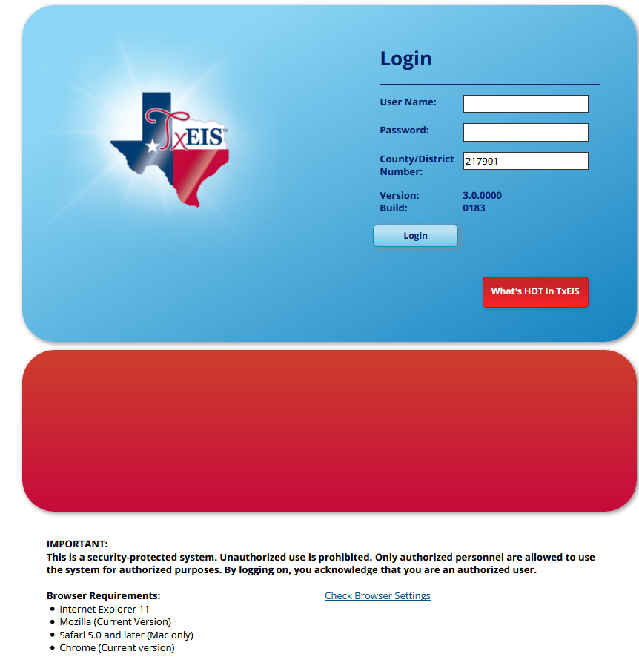

**_____3.** Click on the word **‘here’**.

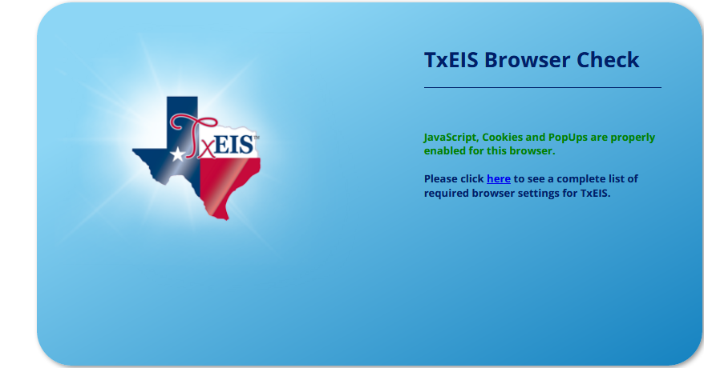

**____4. The TxEIS Browser Settings Document.**

Scroll through the TxEIS Browser Settings document until you reach your browsers instruction. Each required setting is defined.

**____5. Another setting to verify if you are having problems locating your Saved Downloads or Documents:**

**Firefox**: Open Menu (tools menu ) > Options > General > Downloads > click on the Radio button for ‘**Always ask me where to save files**’.

**Chrome:** click on Customize and control Google Chrome (top right of the bar)  > Settings > Scroll to the bottom of page and click on **‘Show advanced settings’ >** Scroll down to **Downloads** > check – ‘**Ask where to save each file before downloading.’**

**____6. Close Browser to Save changes.**

**Note #1: We have attached the current TxEIS Browser Settings as of 5/3/2017. The instructions for the Browser settings may change if the Browser makes any changes. If the attached setting does not match your Browser setting screen, then you will need to pull an updated TxEIS Browser Settings. See Step 2.**

**Note #2: If your browser setting looks correct and you are still having trouble, contact Region 14 TxEIS Business Consultants for additional help.**

**TxEIS Browser Settings**

*Updated July 2016*

The TxEIS Browser Settings document lists supported browsers and recommended browser settings which will allow you to utilize the TxEIS system at its fullest potential on any personal computer.

***Supported Browsers***

Currently, Internet browsers supported by the TxEIS system include the following: For PC users:

* Internet Explorer (IE) 11
* Mozilla Firefox (current version)
* Chrome (current version) For Mac users:
* Apple Safari 5.0 and later (Mac only)

**Note**: Safari is the only browser that TxEIS supports on the Mac.

Please check your browser settings to ensure that your browser is set up to accommodate the browser setup requirements on the next page.

***Screen Resolution***

The recommended screen resolution is 1280 x 1024.

***Task Bar Setup***

Windows 7 allows pages to be opened directly from your task bar. With the TxEIS system, this feature will allow you to easily access different reports, pages, and applications, all from one centralized location. This feature is disabled by default but recommended for TxEIS.

* 1. Right-click the desktop, and select Personalize. The personalization dialog box is displayed.
  2. Under **See also** (located near the bottom-left corner of the dialog box), click **Taskbar and Start Menu**. The Taskbar and Start Menu Properties dialog box is displayed.
  3. On the Taskbar tab under **Preview desktop with Aero Peek**, select *Use Aero Peek to preview the desktop*.
  4. Click **OK**.

Page 1 of 8

***Browser Setup***

**Internet Explorer**

From the Tools menu (), select Internet options. The Internet Options dialog box is displayed with the General tab as the default tab.

***Set Browsing History Options***

On the General tab under **Browsing history**:

1. Click **Settings**.
2. Under **Check for newer versions of stored pages**, select **Every time I visit the webpage**. Click **OK**.
3. Select **Delete browsing history on exit**. Or, click **Delete** to manually delete all browsing history and to clear the cache.
   * If **Delete browsing history on exit** is selected, all browsing history will be deleted, and the cache will be cleared each time you exit Internet Explorer.
   * If **Delete browsing history on exit** is not selected, you can manually delete all browsing history and to clear the cache. Click **Delete**. Select all options except **Preserve Favorites web site data**, and then click **Delete**.

***Display Web Pages as Tabs***

On the General tab under **Tabs**, click **Tabs**.

1. Under **Tabbed Browsing**, select all options except **Open only the first home page when Internet Explorer starts**.
2. Under **When a new tab is opened, open**, select **The new tab page**.
3. Under **When a pop-up is encountered**, select **Always open pop-ups in a new tab**.
4. Under **Open links from other programs in**, select **A new tab in the current window**.
5. Click **OK**.

***Add TxEIS to the Trusted Sites***

Click the **Security** tab.

1. Under **Select a zone to view or change security settings**, select **Trusted sites **.
2. Click **Sites**.
3. In the **Add this website to the zone** field, type the exact website address that you use to access TxEIS, and then click **Add**.

**Note:** If the website address begins with https, select **Require server verification (https:) for all sites in this zone**. If the website address does not begin with https,

Page 2 of 8

ensure that **Require server verification (https:) for all sites in this zone** is not selected.

1. Click **Close**.

***Enable Downloads***

Click the **Security** tab.

1. Under **Select a zone to view or change security settings**, select **Trusted sites **.
2. Click **Custom level**.
3. Under **Settings**, scroll to the **Downloads** section.
4. Under **File download**, select **Enable**.
5. Click **OK**. If any settings were changed, a warning message is displayed confirming the changes. Click **Yes** to continue.

***Enable Pop-up Windows***

TxEIS uses pop-up windows to display reports and other information. The TxEIS website must be set up as an allowed site.

Click the **Privacy** tab.

1. Under **Pop-up Blocker**, select **Turn on Pop-Up Blocker**.
2. Click **Settings**.
   * Under **Exceptions** in the **Address of website to allow** field, type the exact website address that you use to access TxEIS.
   * Click **Add**. The website is displayed under **Allowed sites**.
3. Click **Close**.

***Reset Zoom Level for New Windows and Tabs***

The zoom level for Internet Explorer can be changed at any time from View > Zoom or by using the mouse. However, TxEIS performs best when the zoom level is set to 100%; otherwise, some features may not display correctly.

Click the **Advanced** tab.

1. Under **Accessibility**, select **Reset zoom level for new windows and tabs**.
2. Click **OK**.

Page 3 of 8

**Mozilla Firefox**

From the Firefox tools menu (), select Options. The Options dialog box is displayed with the General tab as the default tab.

***Enable Cookies***

From the Options dialog box, click the **Privacy** icon.

1. Under **History** in the **Firefox will** field, select *Use custom settings for history*.
2. Select **Accept cookies from sites**.

This option should be selected by default. If you do not want to accept cookies from all sites, continue to the next step.

1. Next to **Accept cookies from sites**, click **Exceptions**. The Exceptions - Cookies dialog box is displayed.
   * Under **Address of website**, type the exact website address that you use to access TxEIS.
   * Click **Allow**. The website is displayed under **Site**, and the **Status** is set to **Allow**.
   * Click **Close**.

***Clear History When Firefox Closes***

From the Options dialog box, click the **Privacy** icon.

1. Under **History** in the **Firefox will** field, select *Use custom settings for history*. (This should have been selected in the previous step.)
2. Select **Clear history when Firefox closes**.
3. Click **Settings…**
4. Ensure the following fields are selected:
   * **Active Logins**
   * **Form & Search History**
   * **Cookies**
   * **Cache**
   * Click **OK**.

***Enable Pop-up Windows***

TxEIS uses pop-up windows to display reports and other information. The TxEIS website must be set up as an allowed site.

From the Options dialog box, click the **Content** icon.

1. Select **Block pop-up windows**.

Page 4 of 8

1. Next to **Block pop-up windows**, click **Exceptions**. The Allowed Sites - Pop-ups dialog box is displayed.
   * Under **Address of website**, type the exact website address that you use to access TxEIS.
   * Click **Allow**. The website is displayed under **Site**, and the **Status** is set to **Allow**.
   * Click **Close**.

***Enable JavaScript***

JavaScript must be enabled for the TxEIS website for proper operation of TxEIS.

***In Firefox 22 and earlier:***

From the Options dialog box, click the **Content** icon.

1. Ensure that **Enable JavaScript** is selected.
2. Click **OK**.

***In Firefox 23 and later:***

JavaScript is enabled by default in Firefox 23 and later. To make sure it is enabled follow these instructions.

1. In the address bar, delete the existing website address and type “about:config”. Press ENTER.
2. A warning message is displayed. Click **I’ll be careful, I promise!** The Mozilla Firefox preferences are displayed.
3. In the **Search** field, type “javascript.enabled”. Press ENTER. The result javascript.enabled is displayed.
4. The **Value** column should be true. If it is not, right-click javascript.enabled and select

**Toggle** to enable JavaScript.

1. Close Firefox to save changes. You may need to restart Firefox for the changes to take effect.

***Upload Data When a New Page is Loaded***

1. In the address bar, delete the existing website address and type “about:config”. Press ENTER.
2. A warning message is displayed. Click **I’ll be careful, I promise!** The Mozilla Firefox preferences are displayed.
3. In the **Search** field, type “cache”. Press ENTER.
4. Double-click this setting in the list: browser.cache.check_doc_frequency. The Enter integer value dialog box is displayed.
5. The default value is 3. Change the value to 1. Click **OK**.

Page 5 of 8

1. Confirm the browser.cache.check_doc_frequency value changed from 3 to 1 in the

**Value** column.

1. Close Mozilla Firefox to save the changes.

***Prevent Timeouts (Firefox 30 and later)***

* 1. In the address bar, delete the existing website address and type “about:config”. Press ENTER.
  2. A warning message is displayed. Click **I’ll be careful, I promise!** The Mozilla Firefox preferences are displayed.
  3. In the **Search** field, type “response”. Press ENTER.
  4. Double-click this setting in the list: network.http.response.timeout. The Enter integer value dialog box is displayed.
  5. Replace the existing value with 3600 (or greater). Note that this is the number of seconds. 3600 seconds equals one hour. Click **OK**.
  6. Confirm the network.http.response.timeout value changed accordingly in the **Value**

column.

* 1. Close Mozilla Firefox to save the changes.

Page 6 of 8

**Safari (for Mac)**

From the menu bar, select Safari, and then select Preferences.

***Enable Cookies***

1. From the Preferences dialog box, select Privacy.
2. Next to **Cookies and website data**, select **Allow from websites I visit**.

***Enable Pop-up Windows***

TxEIS uses pop-up windows to display reports and other information. By default, Safari blocks pop-up windows. The pop-up blocker must be disabled for the TxEIS website for proper operation of TxEIS.

1. From the Preferences dialog box, select Privacy.
2. Next to Web content, ensure that **Block Pop-Up Windows** is not selected.

***Enable JavaScript***

JavaScript must be enabled for the TxEIS website for proper operation of TxEIS.

1. From the Preferences dialog box, select **Security**.
2. Next to **Web content**, ensure that **Enable JavaScript** is selected.

***Disable AutoFill***

AutoFill may cause some fields within TxEIS applications to fill automatically.

1. From the Preferences dialog box, select **AutoFill**.
2. Next to **AutoFill web forms**, clear all four check boxes.

Page 7 of 8

**Google Chrome**

To ensure optimal security when using Chrome, you must turn off some default settings using the following steps.

From the Chrome menu (), select Settings. From the Settings page, click **Show advanced settings**.

***Disable Cookies***

1. Under **Privacy**, click **Content settings…**
2. Under **Cookies**, ensure that **Keep local data only until you quit your browser** is selected.

For more information, visit <https://support.google.com/chrome/answer/95421?hl=en>.

***Enable Pop-up Windows***

TxEIS uses pop-up windows to display reports and other information. The TxEIS website must be set up as an allowed site.

1. Under **Privacy**, click **Content settings…**

**2.** Under **Pop-ups**, click **Manage exceptions…**

1. Under **Hostname pattern**, type the exact website address that you use to access TxEIS. Under **Behavior** make sure **Allow** is selected.
2. Click **Done**.

***JavaScript (Enabled by Default)***

JavaScript must be enabled for the TxEIS website for proper operation of TxEIS.

1. Under Privacy, click **Content settings…**
2. Under **JavaScript**, select **Allow all sites to run JavaScript (recommended)**. Or, if you do not want to allow all sites to run JavaScript, click **Manage exceptions…**

In the JavaScript exceptions dialog box under **Hostname pattern** type the exact website address that you use to access TxEIS. Under **Behavior** select **Allow**.

1. Click **Done**.

***Enable AutoFill***

AutoFill may cause some fields within TxEIS applications to fill automatically.

Under **Passwords and forms**, clear **Enable Autofill to fill out web forms in a single click**.

Page 8 of 8